TEMPLATE FOR ABSTRACTS INTERNATIONAL CONFERENCE OF WEIGHING
Tim Hamers, CECIP, tim.hamers@cecip.eu

Length
The abstract should have a maximum of 2 pages The abstract should have a maximum of 2 pages The abstract should have a maximum of 2 pages The abstract should have a maximum of 2 pages The abstract should have a maximum of 2 pages The abstract should have a maximum of 2 pages Th
e abstract should have a maximum of 2 pages The abstract should have a maximum of 2 pages.

File Format
Please send the abstract in MS-Word (.docx or doc) format.

Lay-out: Headline 1

Lay-Out: Headline 2
Please use the styles of standard body text, title, authors, headline 1 and headline 2 (for second level headlines) as provided in this document.
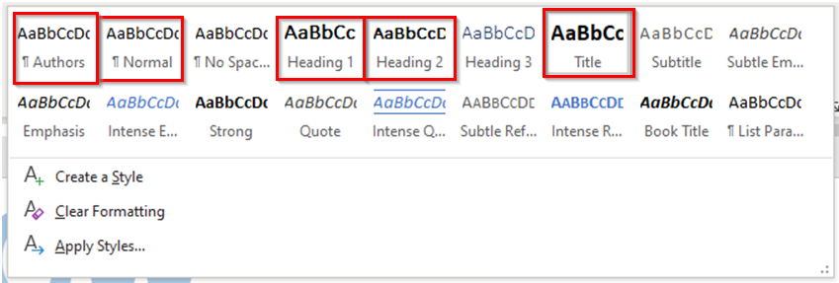
- Standard: Font for the text is Calibri font size 11 (or equivalent) and single-spaced.
- Title: The title should be in the centre in capitals in the Calibri font size 14 (or equivalent). The names of the authors, the organisations they work for and email addresses can be added below in the same font as the rest of the document.
- Headline 1: Headline 1 should be placed on a separate line and be made bold.
- Headline 2: Headline 2 should be placed on the same line and underlined.
- Margins: The margins of the document should be standard.
- SI units should be used correctly and the BIPM guide on ‘The International System of Units’ can be used as a guideline. For numbers, please use the dot ‘.’ as decimal sign in the numbers.

References
References should be included in the following format:
- A. B. Author, Title of Book. New: IEEE Press, Ch. 6, pp. 23-25, 2022.
- J. Q. Author, X. Y. Author, “Title of Paper”, Journal of Metrology, vol. 10, no. 8, pp. 1-20, June 2022.

Due date for the abstract
The due date for sending the abstracts is Friday 16 September 2022.

